PHP Version

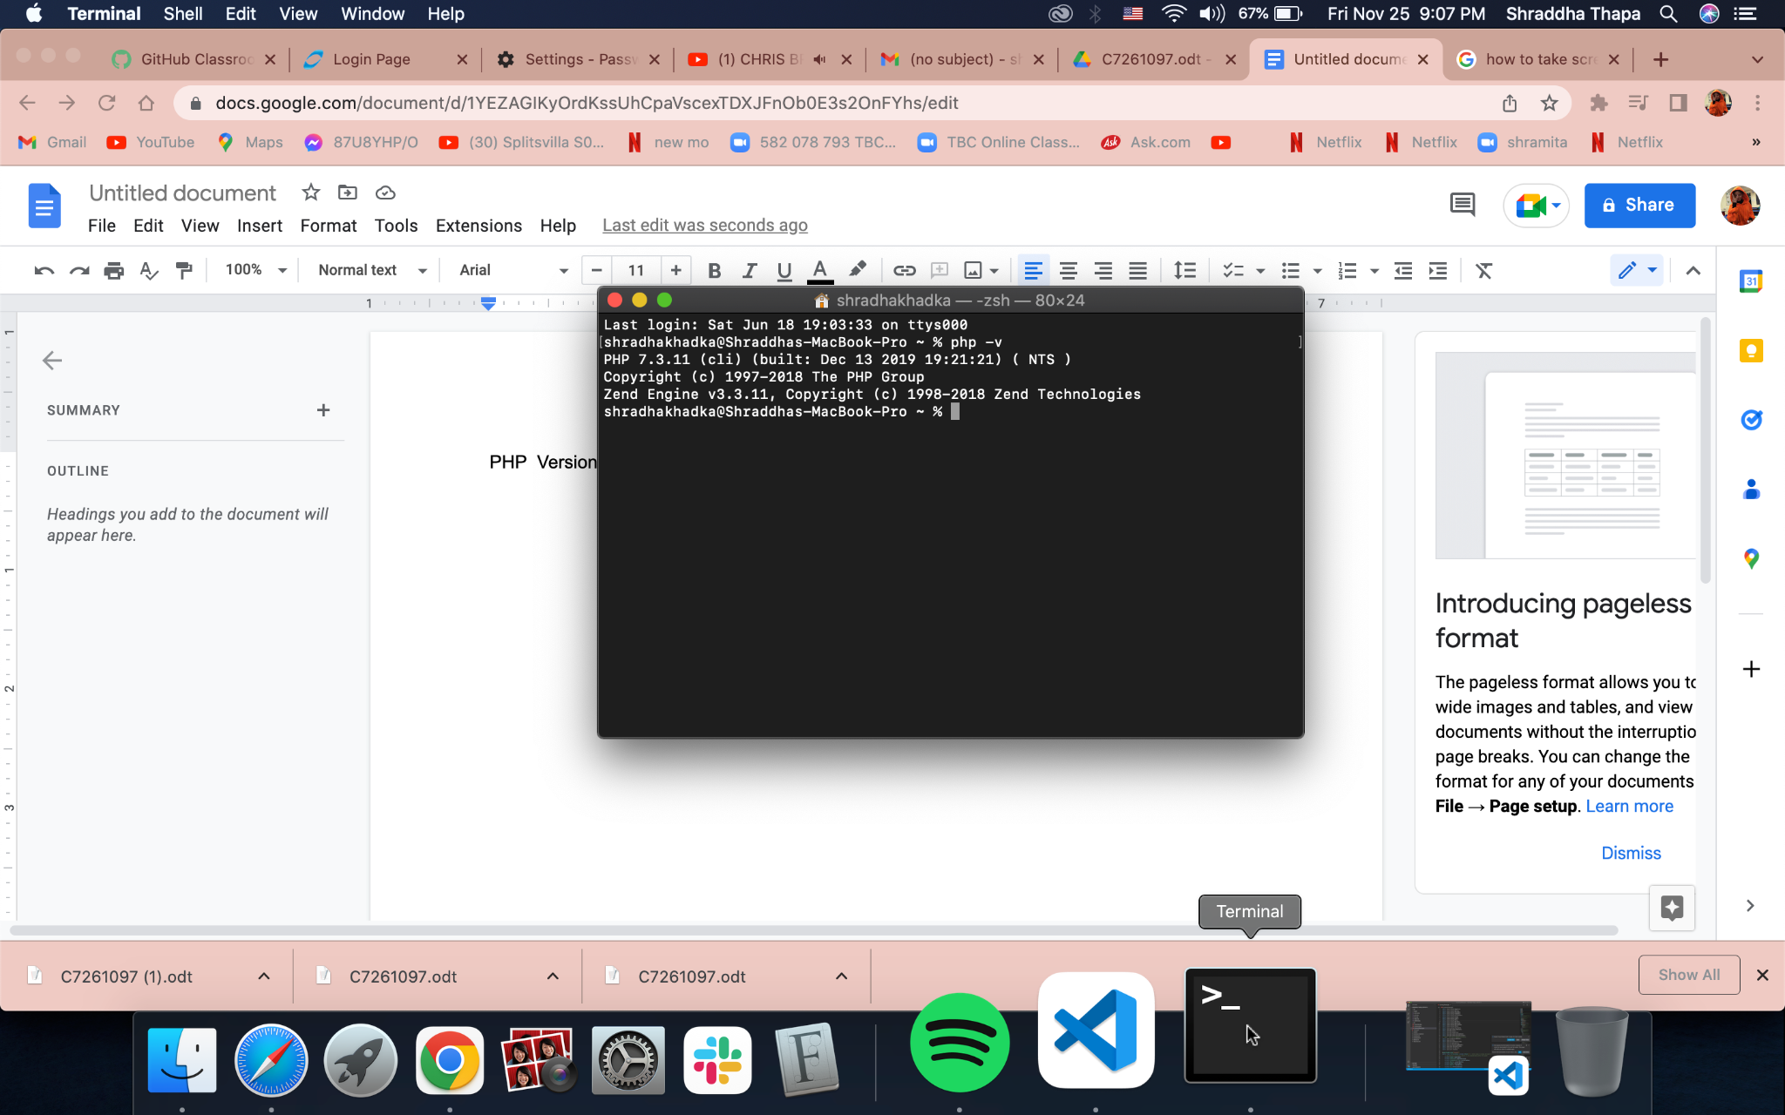

IDE of Choice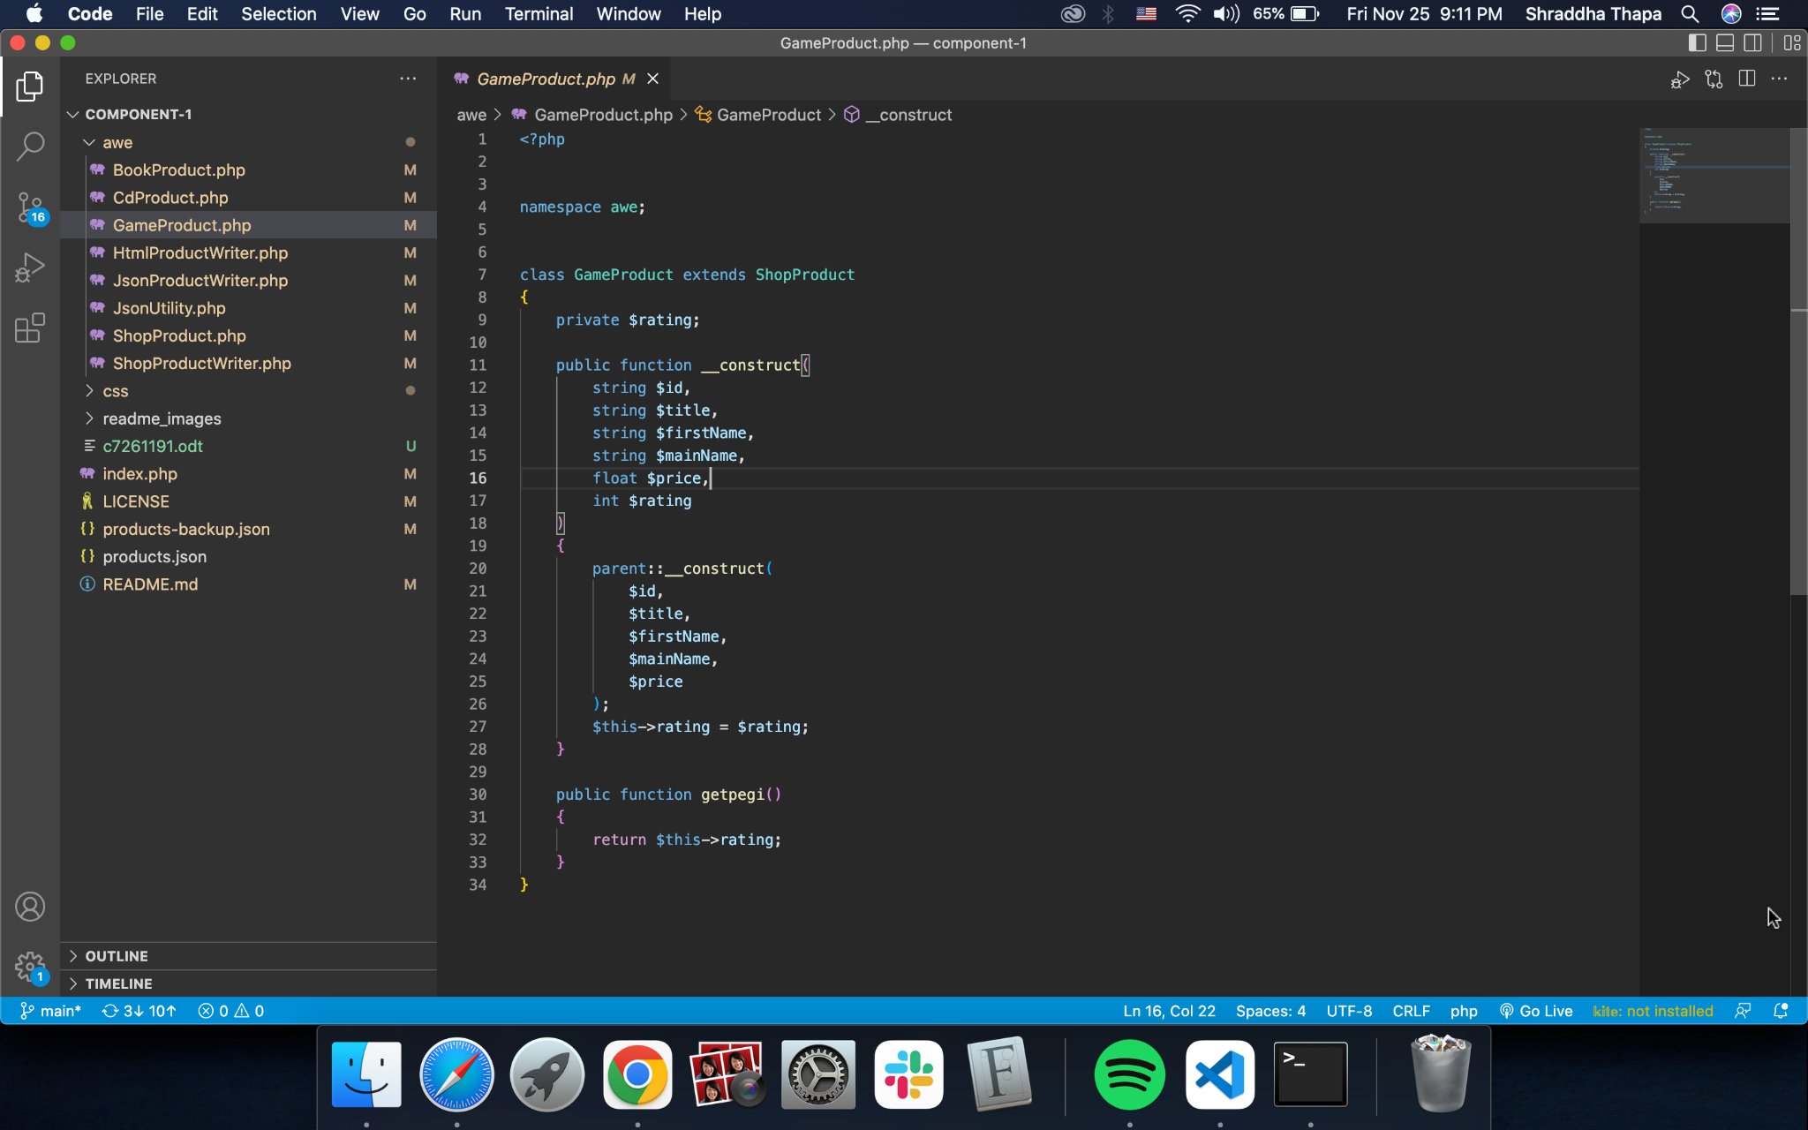

XDebug Installed

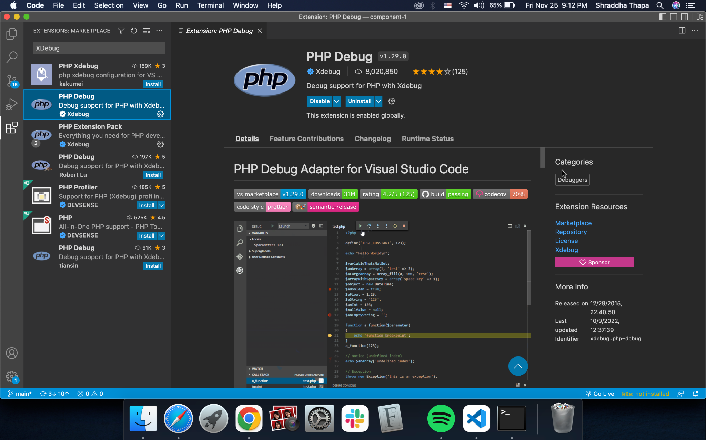

GitHub Account Repo Link: <https://github.com/tbc-bsc-l6/component-1-Shraddhaa2022>

PHP Exercise in Component 1

